**Climate Change Data Analysis**

This report targets the climate change data available on the world bank website. I have selected the following countries for data analysis and compared the data with the overall world. I have only gathered data from 2010 to 2015.

* China
* France
* Germany
* India
* United States
* World

From climate change category I have selected the following three indicators.

* Energy use (kg of oil equivalent per capita)
* Methane emissions (kt of CO2 equivalent)
* Total greenhouse gas emissions (kt of CO2 equivalent)

The statistical summary of the data is listed in the table below.

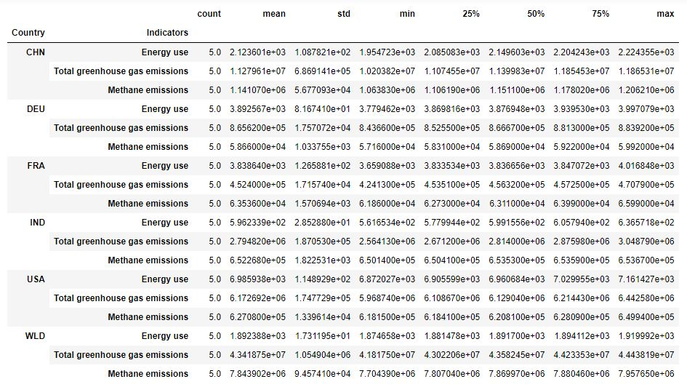

I have performed a correlation analysis of the variables and displayed them in a heatmap. This analysis shows that the ‘Total greenhouse gas emissions’ is highly positively correlated with ‘Methane emissions’ and ‘Energy use’ and ‘Methane emissions’ is also highly positively correlated with ‘Energy use’. This analysis is performed at world level. Individual country level analysis shows the same behavior, details can be seen in the jupyter notebook.

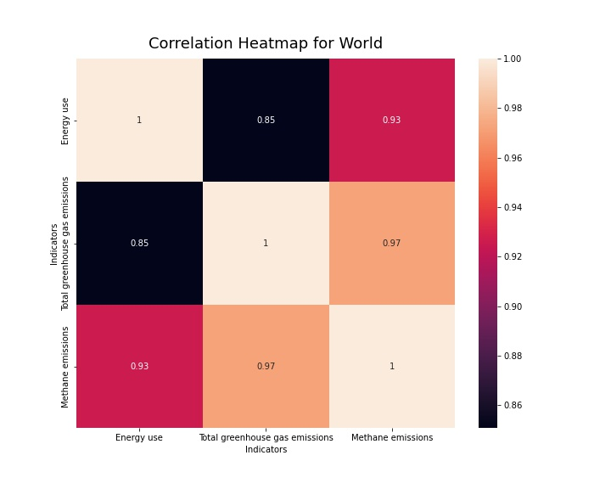

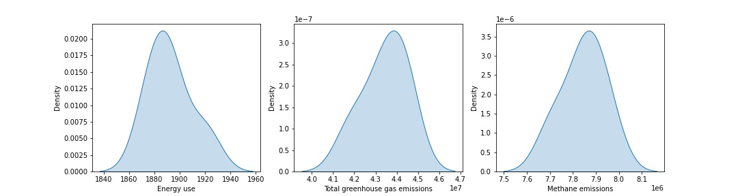

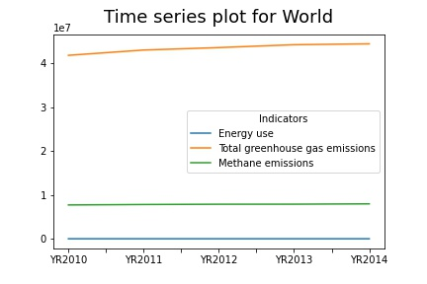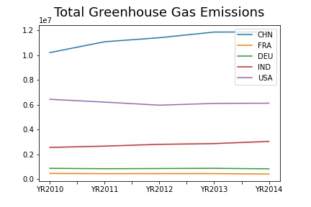

These time series plots highlight the point that Total greenhouse gas emissions have risen over the past few years all over the world. And looking at the right graph we can see that till 2013 China contributed most towards the overall increase in greenhouse gas emissions with India a being the second contributor. USA on the other hand seems to have reduced their emissions and a general falling trend can be seen in the graph. The emissions for France and Germany are constant throughout our study period are the least contributing factors in our dataset.